**ASSIGNMENT**

Student name: Lê Tiến Đạt | HE151019

Student name: Tạ Văn Tân | HE151110

STUDENT NAME: Khương Văn Hùng | HE153096

STUDENT NAME: Nguyễn Duy Hùng | HE153495

STUDENT NAME: Lưu Hoàng Hải | HE153224

Teacher: Phạm Ngọc Thọ

DBI202 – DATABASE SYSTEM OF L LEAGUE OF LEGENDS CHAMPIONS KOREA

July 20, 2021

# TABLE OF CONTENTS

## INTRODUCE THE PROBLEM…………………………………………………………………………………………….

### Describe the problem……………………………………………………………………………………………………….

### Management objectives…………………………………………………………………………………………………..

## entity – relationship – er…………………………………………………………………………………………

### difinITION entity – attributE…………………………………………………………………………………………..

### set-up entity – relationship…………………………………………………………………………………………….

## data dictionary………………………………………………………………………………………………………….

### DATABASE AND TABLE……………………………………………………………………………………….………………….

## ENTITY RELATIONSHIP DIAGRAM (ERD)…………………………………………………………………………

### guard………………………………………………………………………………………………………………………………….

### student……………………………………………………………………………………………………………………………...

### panalize………………………………………………………………………………………………………………………………

### room…………………………………………………………………………………………………………………………………..

### items……………………………………………………………………………………………………………………………………

### normal form…………………………………………………………………………………………………………………….

## SQL COMMAND

### QUERY USING ORDER BY………………………………………………………………………………………………………

### QUERY USING INNER JOIN……………………………………………………………………………………………………

### QUERY USING AGGREGATE FUNCTIONS…………………………………………………………………………………

### QUERY USING THE GROUP BY AND HAVING CLAUSES……………………………………………………………

### QUERY THAT USES A SUB-QUERY AS A RELATION………………………………………………………………….

### QUERY THAT USES PARTIAL MATCHING IN THE WHERE CLAUSE…………………………………………….

### QUERY THAT USES A SELF-JOIN……………………………………………………………………………………………..

### STORE PROCEDURE……………………………………………………………………………………………………………….

### trigger……………………………………………………………………………………………………………………………….

# INTRODUCE THE PROBLEM

## Describe the problem

Nowadays, E-sport is more popular and a lot of tournaments are organized in many countries around the world, attract millions of viewers. **League of Legends Champions Korea (LCK)** is the primary competition for League of Legends esports in South Korea. Contested by ten teams, the league runs two seasons per year (Spring and Summer). The LCK has been long considered one of the strongest League of Legends leagues in the world, with the game's World Championship having been won by teams from the league from 2013 through 2017. With the great attraction from the league, we decided to create a database to manage the LCK tournament.

**Format:**

* The tournament has 10 teams, competing 2 season per year (Spring and Summer).
* In regular season, 10 teams compete in a round robin group stage, matches are best of three and top 6 teams qualify for Playoffs.
* In Playoffs, top 2 teams play from the semi-final, the other four start from the quarter-finals.

All matches in Playoffs are best of five.

* The winner of the Spring Season qualify for the Mid-Season Invitational.
* The winner of the Summer Season (seed 1), the team with the most championship points (seed 2), and the winner of the regional qualifier (seed 3) qualify for the World Championship.

**Request:**

* View player information, team information.
* View organize team (Teachnical, referee..).
* View matches, result, point of every team.
* View winning team, MVP.

## Management objectives

* Manage player and team.
* Manage every matches of tournament.
* Manage matches, time, result.
* Manager organize team.

**Important output**

* Information of all player and team.
* Result of every matches in tournament.
* Information of team organize for each match.

# entity – relationship – er

## difinITION entity – attributE

Base on the problem description and management objectives, we can present several entities and attributes of the entity as follow:

* Player: **ID**, **TeamID, RoleID**, Name, Country.
* Role: **ID**, Description.
* Match: **ID**, **Team1, Team2**, Team1Result, Team2Result, MatchMVP, Date.
* Team: **Name**, Coach.
* Organize: **OrganizeID, MatchID, TakecareID,** Technican, RefereeName, MCName
* Take care: **ID, OrganizeID**, Position

## set-up entity – relationship

* Some symbols used in the model

**Attibute**

|  |  |
| --- | --- |
| * Key / identifier attribute |  |
| * Attribute description / description | **ENTITY**  Attribute |
| * Entity | **WEAK ENTIRY** |
| * Weak entity |  |
| * Relationship | *Relationship* |
| * Connectivity (force) = 1 |  |
| * Connectivity = N |  |

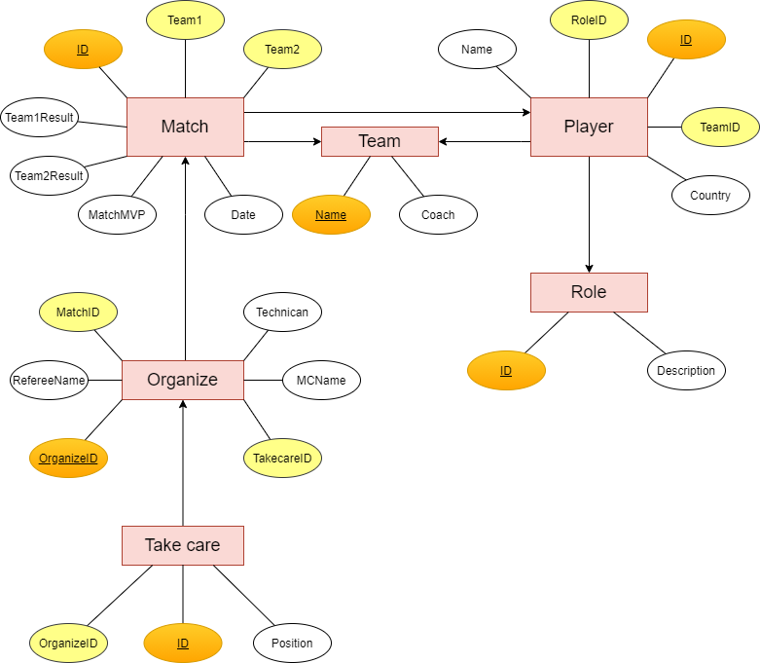

## LINK: <https://drive.google.com/file/d/1IkP_4acuC-PdL0Cu-L5UwHSahNEqTqzn/view?usp=sharing>

# data dictionary

## database and table

### cREATE DATABASE **ASSIGNMENT_DBI202_LCK**

--create database

CREATE DATABASE ASSIGNMENT_DBI202_LCK

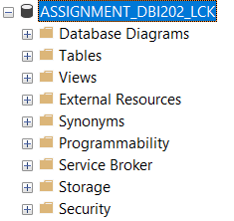

### **Create table PLayer**

| Column Name | Data Type | Default | Check | Key/ Index/ Constraint |
| --- | --- | --- | --- | --- |
| ID | Nvarchar(30) |  |  | Primary key |
| Name | Nvarchar(30) |  |  | Not null |
| Role | Nvarchar(10) |  |  | Not null,  FOREIGN KEY(RoleID) REFERENCES dbo.Role(ID) |
| Country | Nvarchar(10) |  |  | Not null |
| Team | Nvarchar(10) |  |  | FOREIGN KEY(TeamID) REFERENCES dbo.Team(ID) |

***Code:***

--create table player

CREATE TABLE Player

(

ID NVARCHAR(15),

[Name] NVARCHAR(30) not null,

RoleID NVARCHAR(10) not null,

Country NVARCHAR(10) not null,

TeamID NVARCHAR(10),

PRIMARY KEY(ID),

FOREIGN KEY(RoleID) REFERENCES dbo.Role(ID),

FOREIGN KEY(TeamID) REFERENCES dbo.Team(ID)

)

***Example:***

| GuardID | Name | Role | Country | TeamID |
| --- | --- | --- | --- | --- |
| 5kid | Park Jeong-hyeon | Bot Laner | KR | KT |
| Arthur | Park Mi-reu | Jungler | KR | HLE |
| Bang | Bae Jun-sik | Bot lane | KR | AF |

### **Create table Role**

| Column Name | Data Type | Default | Check | Key/ Index/ Constraint |
| --- | --- | --- | --- | --- |
| ID | Nvarchar(10) |  |  | Primary key |
| Description | Text |  |  | Not null |

***Code:***

--create table role

CREATE TABLE [Role]

(

ID NVARCHAR(10) not null,

[Description] TEXT not null

PRIMARY KEY(ID)

)

***Example:***

| ID | Description |
| --- | --- |
| Top Laner |  |
| Jungler |  |
| Mid Laner |  |
| Bot Laner |  |
| Support |  |

### **Create table match**

| Column Name | Data Type | Default | Check | Key/ Index/ Constraint |
| --- | --- | --- | --- | --- |
| ID | Int |  |  | Primary key |
| Team 1 | Nvarchar(10) |  |  | Not null, FOREIGN KEY(Team1) REFERENCES dbo.Team(ID) |
| Team 2 | Nvarchar(10) |  |  | Not null, FOREIGN KEY(Team2) REFERENCES dbo.Team(ID), |
| Team 1 Result | Int |  |  | Not null |
| Team 2 Result | Int |  |  | Not null |
| Date | Date |  |  |  |
| MatchMVP | Nvarchar(15) |  |  | Not null, FOREIGN KEY(MatchMVP) REFERENCES dbo.Player(ID) |

***Code:***

CREATE TABLE [Match]

(

ID INT,

Team1 NVARCHAR(10) NOT NULL,

Team2 NVARCHAR(10) NOT NULL,

Team1Result INT,

Team2Result INT,

[Date] DATE,

MatchMVP NVARCHAR(15),

PRIMARY KEY(ID),

FOREIGN KEY(Team1) REFERENCES dbo.Team(ID),

FOREIGN KEY(Team2) REFERENCES dbo.Team(ID),

FOREIGN KEY(MatchMVP) REFERENCES dbo.Player(ID)

)

***Example:***

| ID | Team 1 | Team 2 | Team 1 result | Team 2 result | Date | Match MVP |
| --- | --- | --- | --- | --- | --- | --- |
| 1 | KT | T1 | 0 | 2 | 1/9/2021 | Hoit |
| 2 | NS | DRX | 1 | 2 | 1/7/2021 | Effort |
| 3 | HLE | NS | 1 | 2 | 1/5/2021 | Dove |

### Create TABLE team

| Column Name | Data Type | Default | Check | Key/ Index/ Constraint |
| --- | --- | --- | --- | --- |
| ID | Nvarchar(10) |  |  | Primary key |
| Coach | Nvarchar(10) |  |  | Not null |

***Code:***

--create table manager team

CREATE TABLE Team

(

ID NVARCHAR(10),

Coach NVARCHAR(10)

PRIMARY KEY(ID)

)

***Example:***

| ID | Coach |
| --- | --- |
| AF | 8571 |
| BRO | 55141 |
| DRX | 87469 |

### create table oganize

| Column Name | Data Type | Default | Check | Key/ Index/ Constraint |
| --- | --- | --- | --- | --- |
| OrganizeID | Int |  |  | Primary key |
| MatchID | Int |  |  | FOREIGN KEY(MatchID) REFERENCES dbo.Match(ID) |
| TakecareID | Int |  |  |  |
| RefereeName | Nvarchar(20) |  |  |  |
| Technican | Nvarchar(20) |  |  |  |
| MCName | Nvarchar(20) |  |  |  |

***Code:***

--create table register

CREATE TABLE Organize

(

OrganizeID INT,

MatchID INT,

TakecareID INT,

RefereeName NVARCHAR(10),

Technican NVARCHAR(20),

MCName NVARCHAR(30)

PRIMARY KEY(OrganizeID)

FOREIGN KEY(MatchID) REFERENCES dbo.Match(ID),

)

***Example:***

| OrganizeID | MatchID | TakecareID | RefereeName | Technican | MC name |
| --- | --- | --- | --- | --- | --- |
| 1 | 69 | 43 | Melvin | LI 39 11 60 I | Salvatore0 |
| 2 | 83 | 99 | Harvey | OA 35 40 14 S | Larry |
| 3 | 4 | 52 | Malcolm | QM 72 75 59 K | Marshall |

### create table take care

| Column Name | Data Type | Default | Check | Key/ Index/ Constraint |
| --- | --- | --- | --- | --- |
| ID | Int |  |  | Primary key |
| Position | Nvarchar(20) |  |  |  |
| OrganizeID | Int |  |  | FOREIGN KEY(OrganizeID) REFERENCES dbo.Organize(OrganizeID) |

***Code:***

--create table items

CREATE TABLE [Take care]

(

ID INT,

Position NVARCHAR(20),

OrganizeID INT,

PRIMARY KEY(ID),

FOREIGN KEY(OrganizeID) REFERENCES dbo.Organize(OrganizeID)

)

***Example:***

| ID | Position | OrganizeID |
| --- | --- | --- |
| 1 | Technical | 5 |
| 2 | Prepaid Customer | 6 |
| 3 | Prepaid Customer | 17 |

### 

# IV. entity relationship diagram (erd)

## Player

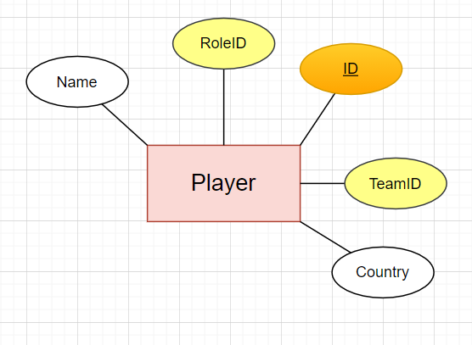

|  |  |
| --- | --- |
| This is the Player entity. Entity has 5 attributes. The ID attribute is the primary key of this entity. Each player has a Name, Role, Team and Country. In which, Role is RoleID, Team is TeamID. |  |

## Role

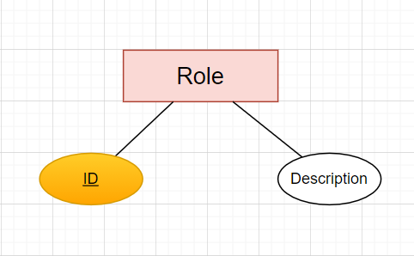

|  |  |
| --- | --- |
| This is the Role entity. Entity has 2 properties. The ID attribute is the primary key of this entity. Each role has a description describing that role. |  |
|  |  |

## Match

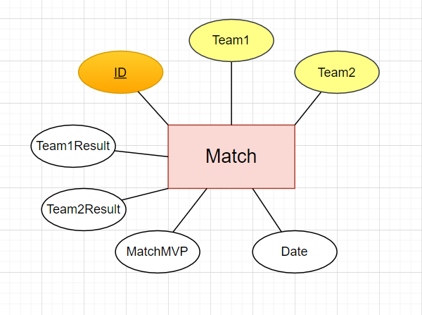

|  |  |
| --- | --- |
| Two teams play against each other called a match. It knows the names of two teams that play against each other like Team1 and Team2. The ID is the primary key to know which match it is and Day indicates what day the match will take place. Finally, Team1Result and Team2Result are the number of games won by the two teams after the match. |  |
|  |  |

## Team

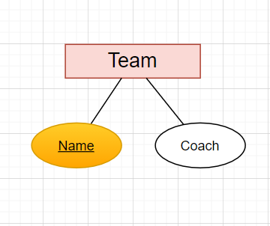

|  |  |
| --- | --- |
| The Team entity has 2 properties. Name is the name of the team and is the primary key. Each team will have a Coach. |  |
| Organize |  |

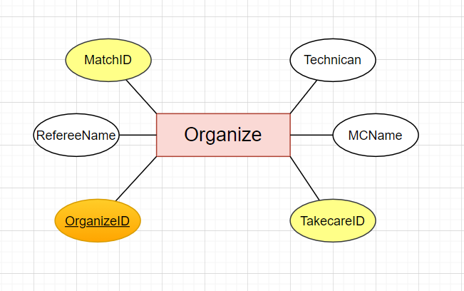

|  |  |
| --- | --- |
| The Organize entity has 6 properties. Each organization of a match needs technicians, referees, MCs, Take Care. With OrganizeID as the primary key. |  |

|  |  |  |
| --- | --- | --- |
| Take care  |  |  | | --- | --- | | Each Take Care squirrel has a Position. Take Care entity has 3 properties where ID is primary key which is the name of the caregiver and the OrganizeID indicates which organization the caregiver works for. |  |  full diagram |

# V. sql command

## query using order by

## query using inner join

## query using aggregate function

## query using the group by and having clauses

## query that uses a sub-query as a relation

## query that uses partial matching in the where clause

## query that uses a self – join

## store procedure

## trigger

THE END